SUMMERVILLE CREDIT UNION · CONSOLIDATED MEMBER GUIDE · CSUM-24 of 30
Recent Activities & My Insights

Module: nFinia Digital Banking > More > Recent Activities / My Insights
Sources: Summerville Reports Series A (36 docs) + Series B (25 docs) | Features: nFinia Documentation Features Spreadsheet
01 PRODUCT SUMMARY

Recent Activities provides a real-time log of all significant account events since the member's last login — transfers initiated, payments made, login events, alert triggers, and form submissions. It serves as an immediate session security audit, allowing members to quickly verify that no unexpected actions occurred since their previous session.
My Insights delivers personalised spending analytics and financial intelligence based on the member's transaction history. Transactions are automatically categorised by merchant type, enabling members to see spending breakdowns by category (groceries, dining, utilities, entertainment), income vs. spending trends, and cash flow patterns. The Insights tab provides category-level drill-down with individual transaction detail.
Together, Recent Activities and My Insights give members both a security-focused retrospective (what happened) and a financial intelligence view (how money is being spent) — two complementary lenses on their account activity.

At a Glance

Attribute | Detail
Module | More > Recent Activities & My Insights
Recent Activities | All events since last login in reverse chronological order
Insights Categorisation | Automatic merchant category code-based transaction grouping
Insights Views | Overview (income vs. spend), Insights tab (category breakdown)
Data Source | Transaction history across all accounts in active membership
Related Reports | CSUM-02 (Dashboard), CSUM-03 (Account Overview)

02 KEY USE CASES

Use Case | Who Uses It | What They Do | Business Value
Post-Login Security Check | Members verifying no unauthorized activity | Review Recent Activities immediately after login | Instant detection of unauthorized transfers or login events
Monthly Spending Review | Members reviewing their spending categories | Open My Insights for category-level spending breakdown | Identifies over-spending areas at a glance without manual ledger review
Income vs. Spending Comparison | Members monitoring monthly cash flow | View Overview in My Insights for income/expense totals | Quick cash flow health check with no manual calculation required
Transaction Audit | Members researching where money was spent | Drill into a spending category in Insights to see all transactions | Data-driven basis for identifying and reducing discretionary spending

03 STEP-BY-STEP GUIDE

Navigation: Dashboard > More > 'Recent Activities' OR 'My Insights'.

Step 1 — Start from Dashboard
The member begins at the Dashboard after logging in. The Dashboard displays all account balances, upcoming payments, quick-action tiles, and the top navigation bar with links to Accounts, Move Money, and More.
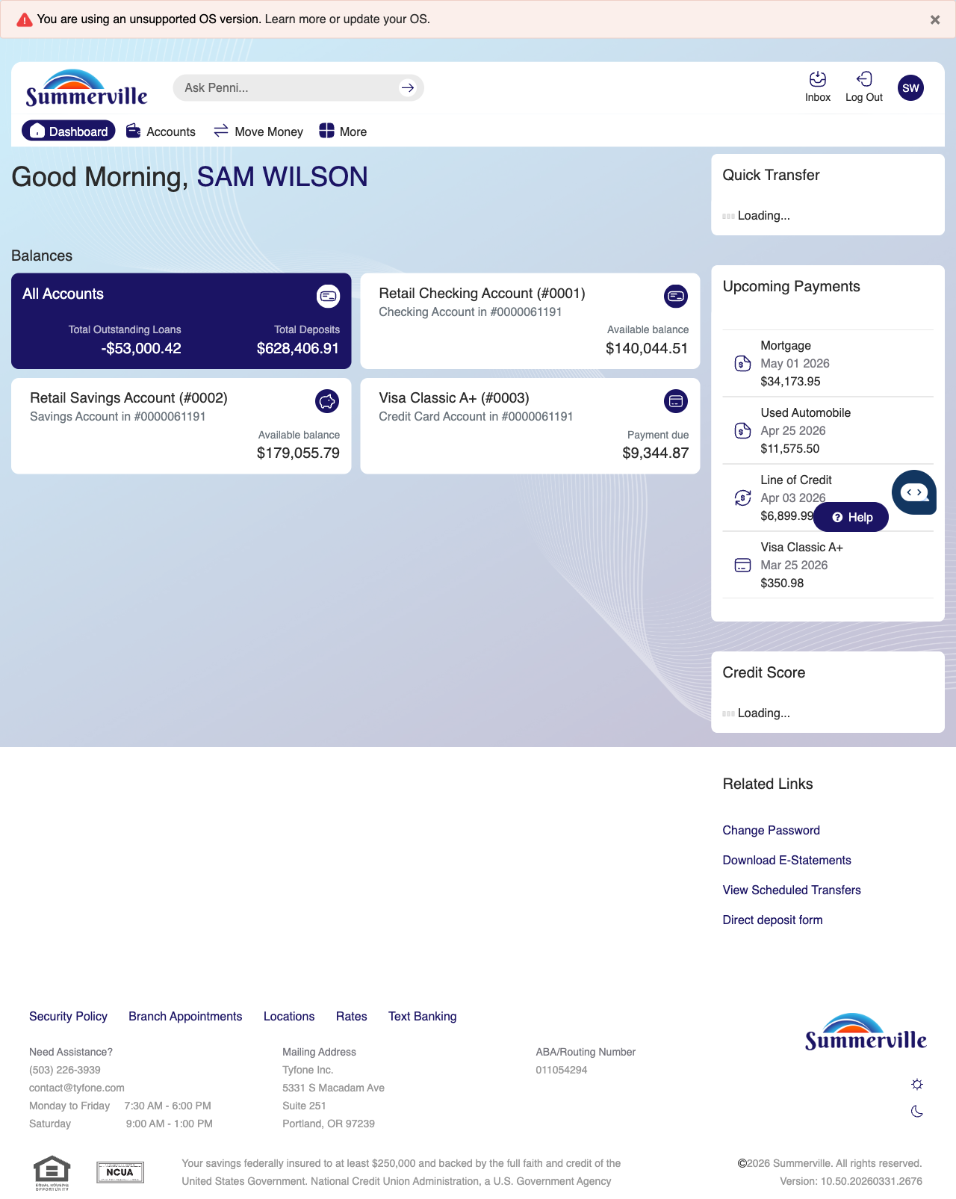
Step 1: Start from Dashboard

Step 2 — Open the More Menu
The member clicks ‘More’ in the top navigation bar. The More options panel expands to show additional features: Check Deposit, User ID and Password, eDocuments, Account Alerts, General Alerts, Password, Forms, One-Time Passcode, Skip A Pay, Do-Not-Disturb, Manage Devices, My Insights, Alert Settings, Recent Activities, and Card Services.
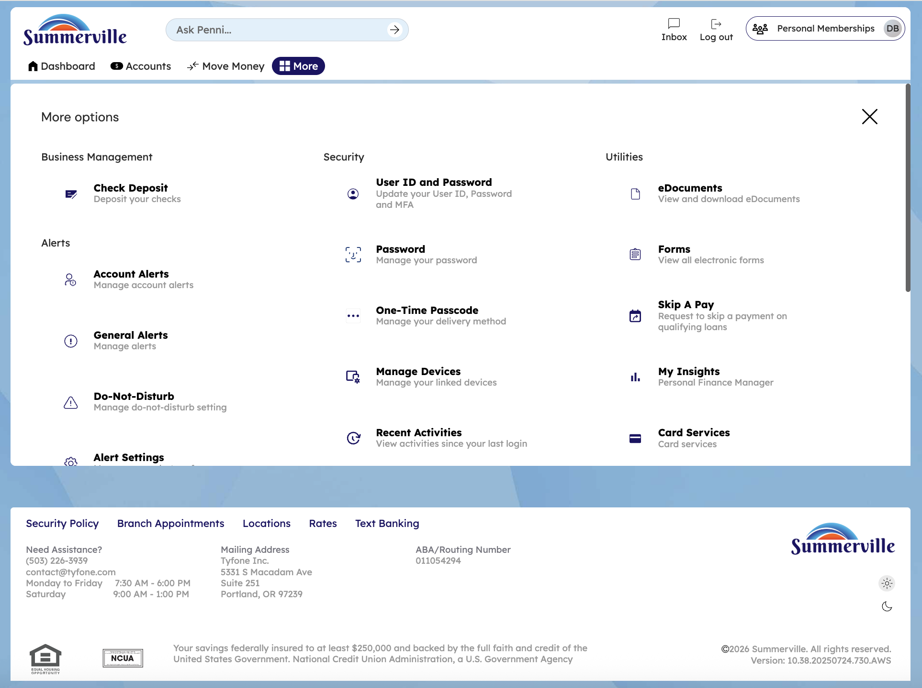
Step 2: More Menu

Step 3 — Navigate from Dashboard to Recent Activities
The Recent Activities modal is displayed showing a chronological list of the member's actions since their last login, each entry with a timestamp and activity description.
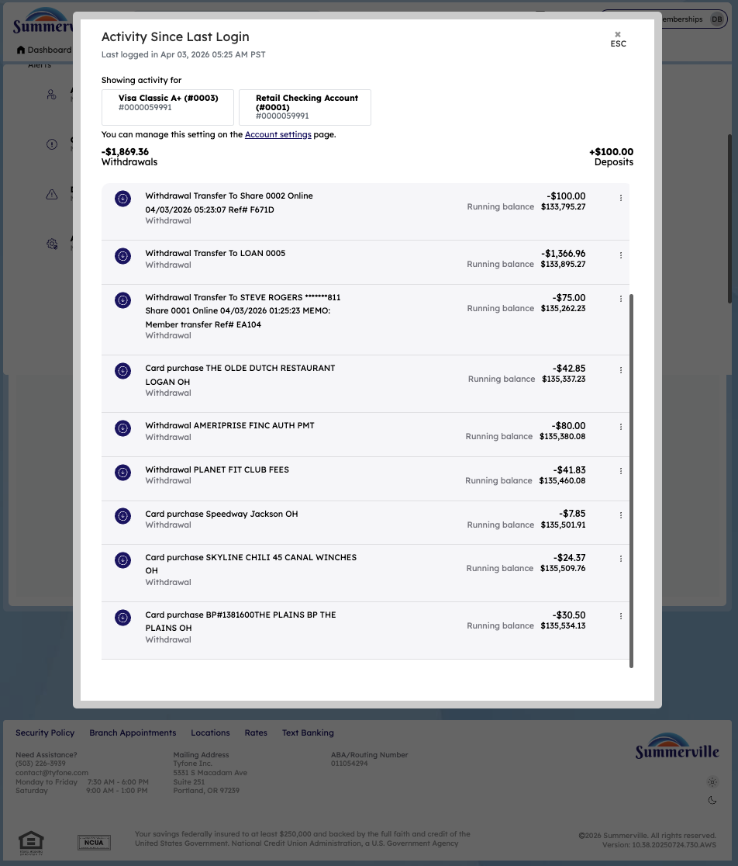
Step 3: Navigate from Dashboard to Recent Activities

Step 4 — Navigate from Dashboard to My Insights Overview
The My Insights dashboard page is shown with various financial insight cards and a promotional advertisement banner displayed alongside the analytics content.
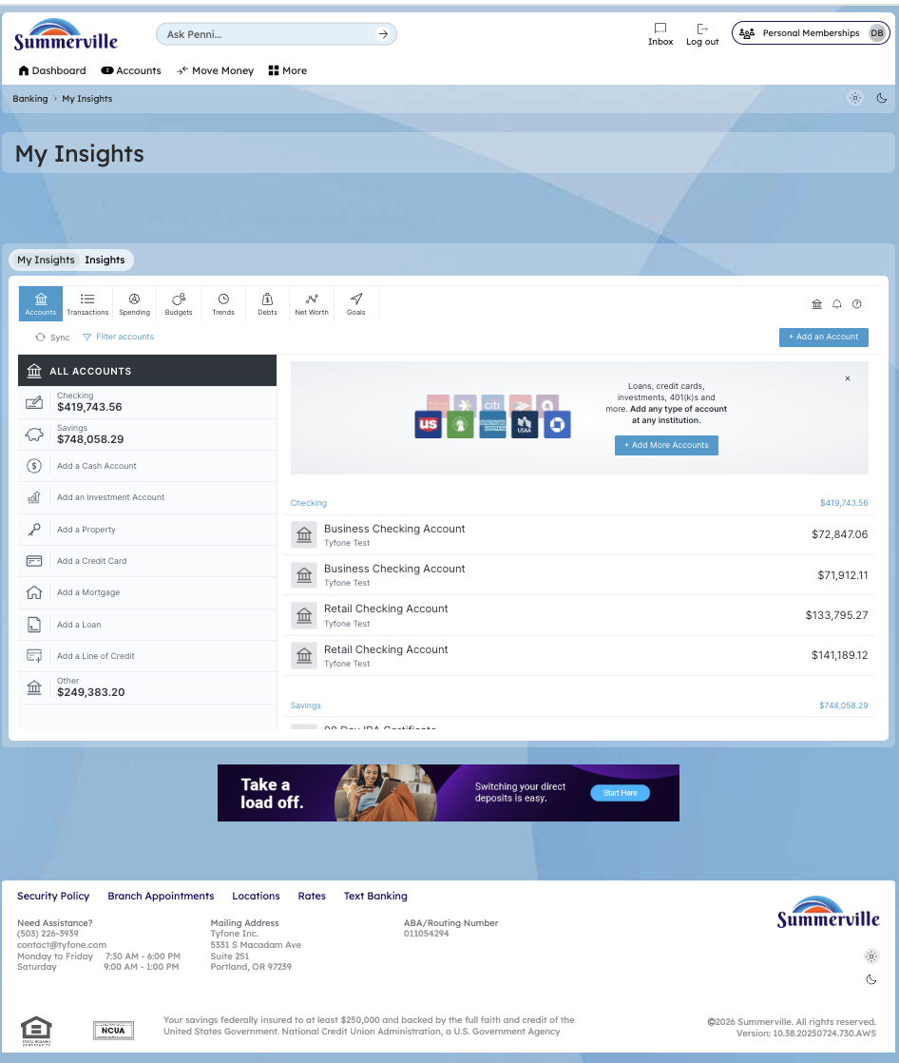
Step 4: Navigate from Dashboard to My Insights Overview

Step 5 — Explore Insights Category Breakdown
The My Insights page displays a metrics card showing account balance information and financial trend data for the member's spending and income analysis.
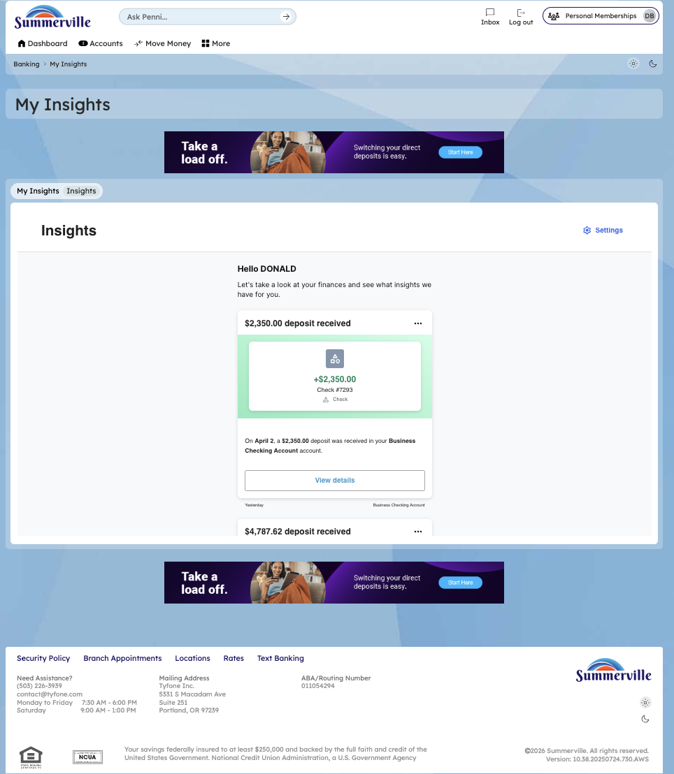
Step 5: Explore Insights Category Breakdown

